**AYURVEDIC SKIN DISEASE DETECTOR**

Project Id: 2020-010

Project Proposal Report

L.P.H Perera (IT17021326)

B.Sc. (Hons) Degree in Information Technology

Department of Information Technology

Sri Lanka Institute of Information Technology

Sri Lanka

February 2020

**AYURVEDIC SKIN DISEASE DETECTOR**

Project Id: 2020 – 010

Project Proposal Report

L.P.H Perera (IT17021326)

B.Sc. (Hons) Degree in Information Technology

Department of Information Technology

Sri Lanka Institute of Information Technology

Sri Lanka

February 2020

# **Declaration, copyright statement and the statement of the supervisor**

We declare that this is our own work and this proposal does not incorporate without acknowledgement any material previously submitted for a degree or diploma in any other university or Institute of higher learning and to the best of our knowledge and belief it does not contain any material previously published or written by another person except where the acknowledgement is made in the text.

|  |  |  |
| --- | --- | --- |
| Name | Student ID | Signature |
| L.P.H Perera |  |  |

The supervisor/s should certify the proposal report with the following declaration.

The above candidates are carrying out research for the undergraduate Dissertation under my supervision.

Signature of the supervisor: Date

**Abstract**

Sri Lanka has always been a country which was prominent for its traditional medicines, special herbs and ointments from times past. The abundance of these natural herbs within the country has allowed it share a rich and vast history in Ayurvedic treatments. However, these medications and ancient treatments have been largely lost at present with only a few practitioners being present within the country. However, this does not deny the effectiveness of these treatment nor their importance, especially for those diseases that do not have proper treatments through Western medications. Various skin diseases also fall under the category of such diseases that can be treated effectively through Ayurvedic medicine. However, due to the hectic lifestyles led by people today, they often do not have the time and energy to submit themselves to regular checkups and treatments even to a regular doctor [1] let alone take the time to seek out and meet an Ayurvedic doctor. Due to this, there exists the need for a quick and easy way that people can seek out Ayurvedic treatments without having to physically visit the doctor themselves. For this purpose a chatbot application which diagnoses skin diseases and then provides recommendations for relevant Ayurvedic treatments that can be followed is suggested. The system will follow a general question and answer type format for the diagnosis in order to eliminate its reliance on graphical imagery [1, 2] of the symptoms exhibited by the user in order to prevent issues that may arise in obtaining such images. Furthermore, depending on the severity of the condition exhibited by the user, the system may further recommend Ayurvedic doctors for treatments, thus eliminating the difficulties faced in finding said doctors. Hence this paper discusses the need for such a system as a solution to the loopholes of existing systems and further touches upon the preferred forms of implementation for the proposed system to identify four skin diseases Psoriasis, Hives, Cold Sores and Actinic Kerosis.

**Table of contents**

Declaration ……………………………………………………………….......iii

Abstract ……………………………………………………………...……….iv

TABLE OF CONTENTS …………………………………………………….v

LIST OF FIGURES ………………………………………………………….vi

LIST OF TABLES …………………………………………………………..vii

1. INTRODUCTION..………………………………………………………..01

1.1 Background ………………………………………………………01

1.2 Literature Review ………………………………………………..02

1.3 Research Gap …………………………………………………….04

1.4 Research Problem ………………………………………………..06

2. OBJECTIVE.……………………………………………………................07

2.1 Main Objective …………………………………………………...07

2.2 Specific Objectives ……………………………………………….07

3. METHODOLOGY………………………………………………................08

4. WORK BREAKDOWN STRUCTURE …………………………………..12

5. COMMERCIAL VALUE…………………………………………..……...13

6. GANTT CHART ………………………………………………………......14

7. REFERENCES ………………………………………………………….....15

**List of figure**

Figure 3.1 Implementation process followed by the proposed system

Figure 3.2 Prescription of the process

**List of tables**

Table 3.1 Comparison Table

**1. Introduction**

**1.1 Background**

Personal health is an extremely important aspect of an individual’s life. A healthy individual is in turn able to lead a better life style and contribute greater to a better society. However, due to the busy lifestyle led by people in the current society, their personal health has become a factor that is often overlooked in favor of the rush for money and completely the heavy workloads they carry. It has come to a point where many people today neglect their health until small issues build up within them leading to much larger complications which a harder to cure [1]. Skin diseases are also one such group of illnesses that if left unchecked could progress beyond control. Additionally, most skin diseases once progressed enough to be visible to others, also cause severe self-esteem issues and create an uncomfortable environment for that said individual to live in on a daily basis. Furthermore, prolonged conditions such as this can also lead to other mental conditions that are in an overall sense highly detrimental to a person’s wellbeing and their ability to function in society.

Hence, it is always recommended that these diseases be identified and treated at the earliest possible stages to prevent these undesirable eventualities. Though many people prefer Western medicine at this day and age, it has been proven many times that Ayurvedic medicine and medicinal practices are much more effective in treating such diseases than their Western counterparts. Due to this, in recent times people have begun seeking out Ayurvedic medications for their ailments more and more. However, there are few major problems that many individuals encounter when seeking medical help from these avenues. One such issue is the difficulty that many face in finding Ayurvedic doctors who practice these ancient treatments and meeting them. Moreover, due to the hectic lifestyles of people today, it has become especially more challenging to seek out medical help from any avenue including Ayurvedic medicine. As there are very few substitutes to the practitioners of Ayurvedic medicine and its ancient teachings it is even more difficult to get the required advice for treating these diseases through Ayurvedic medicine in recent times.

Hence the proposed solution, a chatbot for diagnosing skin diseases and treating them via Ayurvedic medications is suggested to combat the problems stated above, i.e. the inability of people to take time away from their hectic lifestyles to attend to their medical needs and the inability to find suitable Ayurvedic medicinal solutions or practitioners to diagnose and treat skin diseases. The proposed system will be designed to identify the ailment of the patient by analyzing a set of questions and answers that will be obtained by the chatbot when conversing with the patient and hence provide a diagnosis and possible treatment plan in accordance with the Ayurvedic medicinal practices accepted by it. The system will be designed to successfully detect four different skin diseases, namely,

1. Psoriasis
2. Hives
3. Cold Sores
4. Actinic Kerosis

**1.2 Literature Review**

Over time there have been many attempts to use digital means in the diagnosis of human diseases to provide more accurate and timely responses. The main factors to be noted in the studies carried out so far are as follows.

Diagnosis of human diseases through digital means have employed many different approaches as at present. The main approaches out of these include the use of chatbots and image recognition in identifying diseases. The use of natural language processing (NLP) technology is highly prevalent in such applications for text recognition and classification [1, 4].

Considering the use of chatbots in disease recognition, there have been a number of applications following this perspective. The main goal cited by these systems has been to provide a conversational agent to users that can replicate the traditional medical diagnosis scenario where the patient would have to physically visit the doctor and receive a diagnosis based on their symptoms [1, 3]. These systems have been identified to target users with rather hectic lifestyles to help them compensate for the lack of time to physically visit a doctor and receive a diagnosis. The systems that have been created thus far are typically reserved for Western medicine and typical medical diagnosis and treatment suggestions. Hence the proposed system will differ from these in the aspect that it is specifically for providing Ayurvedic medications for skin diseases.

Another factor to be noted is that most existing systems that are used to diagnose skin diseases do so by making use of certain graphical representations, i.e. by classifying photos and images depicting symptoms of the diseases accordingly [2, 3, 5]. However, it should be considered that there are certain cases where such graphical representation is not practical when considering the user’s perspective and also that the graphical means alone might not provide the most correct diagnosis as there may be other underlying medical situations that are indirectly causing the disease. This is addressed by the proposed system by providing a question and answer type of environment that allows the system to gain a wider variety of information regarding the symptoms exhibited by the user while also catering to those users who cannot or prefer not to provide a graphical representation of their symptoms.

Considering past literature, a system which employs image processing and machine learning algorithms [2] has been used to identify three skin diseases, Eczema, Melanoma and Psoriasis. Another system referenced by [3] uses the same image processing techniques to identify a wider variety of skin diseases including Warts, Tinia Corporis, Acne, Vitiligo, Psoriasis and Eczema. In both these cases, the treatment suggested is the typical Western medications and while both systems rely primarily on image processing techniques which in other words suggest the need of some graphical representation for the disease symptoms. It should also be noted that no existing system provides diagnosis and treatment for diseases through Ayurvedic Medications. Hence the proposed system will be a unique solution to this problem domain.

**1.3 Research Gap**

Taking into consideration the various research areas and solutions that have been presented on the topic of disease diagnosis through digital means, there have been studies that encompass a wide variety of areas in this field. These areas mainly include the use of chatbots for the diagnosis of common human diseases, the use of image processing and graphical representations for the process of identifying skin diseases specifically and the application of Western medical practices by systems when suggesting possible courses of treatments and/or recommendations towards doctors for further examination. In this case it can be identified in the significant lack of methodologies and exploration into such methodologies for certain niche areas of these studies as follows.

Firstly, in consideration of the usage of chatbots and related applications in the study if diagnosis of human diseases, it should be noted that such applications are mainly aimed at providing users with the same experience as they would get when physically visiting a doctor for a checkup. While this is the main goal, it is identified that many applications cover a range of common and rather generic diseases that may be easily identified via some question and answer type of communication between the user and the system [1]. However, it should also be noted that these studies quite rarely venture into more specific categories of disease such as skin diseases which are to be handled by the proposed system.

Secondly, with regards to the methodologies used to technologically determine the diagnosis of a skin disease, it is identified that the main methodology used is image processing techniques coupled with Machine Learning algorithms such as KNN and CNN [2, 4, 5]. While this has been cited in many literature as the most effective method, there also exists a lesser popular area of handling such classifications through the use of text processing rather than image processing [6]. Studies into this particular area of research are not as prominent or as frequent as its counterpart using image processing, but will be put into use via the proposed system.

Finally, another notable exclusion from existing studies and literature is the usage of traditional medicine practices and addressing of hardships that come with following such practices. Though there are many systems that cater to modern medical needs and practices, the same cannot be said for traditional medicine. There are also many unique challenges that arise when users attempt follow and find further information on such practices including Ayurvedic treatments. The distinct lack of research catering to these specific areas is identified in this situation and is hence addressed upon by the proposed solution.

**1.4** **Research Problem**

The research problem for this study is identified as the lack of existing digitized solutions for identifying and treating skin diseases through Ayurvedic medications. As noted within the previous sections, digitized solutions for human disease diagnosis are largely specific for Western medications and treatments and furthermore, primarily make use of image processing techniques for diagnosis purposes [1]. This however does not address two prominent concerns that arise within this field regarding classification of diseases using non-graphical means and providing solutions exclusively for Ayurvedic treatments. These concerns are further elaborated in a research perspective as follows.

Considering the usage of image processing technology for the purpose of identifying skin diseases, it can be noted that this is the most common form of technology and process which is used in this event [5]. However, it should also be noted that this process is unsuitable for those diseases or situations where it is not possible to provide an image of the symptoms into the system. This may be due to practicality issue or a personal preference, but it still does not overcome the fact that disease diagnosis should be available to users even in those situations. Hence, the problem is identified as the lack of alternatives that cater to such user situations via typical image recognition processes.

Additionally, another problem area that is identified with relation to the current research domain is the specificity of implemented solutions towards modern or Western medicinal practices. Most solutions and medical diagnosis systems implemented thus far recommend such treatment procedures and doctors within the typical medical setting. However, they often do not consider the solutions provided through traditional medicine and also do not take into consideration the difficulties faced by users in contacting Ayurvedic doctors for further consultations. Hence, the proposed system also hopes to address these concerns to provide a better solution encompassing all the needs of a user within these aspects.

**2. OBJECTIVE**

**2.1 Main Objectives**

Following the identification for the requirement of a system similar that which is proposed in this document, the main objective of the chatbot for diagnosing and treating skin diseases using Ayurvedic medicine is to allow users to receive reliable diagnosis for skin diseases through non-graphical means so as to better cater to those users whose diseases cannot be properly identified through graphical mediums and similar representations.

**2.2 Specific Objectives**

Further, specific goals and objectives of the proposed system are as follows.

1. Allow the system to generate questions to be asked from the user that will then be used to identify the symptoms exhibited and come to relevant conclusions. The questions will be such that, initially the user will be presented with generic questions which will in turn become more specific as the information provided by each response is processed by the system.
2. Using Natural Language Processing (NLP) to identify keywords related to each disease and their symptoms from the responses provided by each user.

Depending on the severity of the disease, providing details on Ayurvedic doctors who are practicing treatments for that particular disease in the area of residence of the user.

**3 METHODOLOGY**

This section elaborates on the main design and implementation aspects of the proposed solution. The chatbot application will function similar to other chatbot applications and conversational agents. The user will chat with the chatbot in a manner similar to having a normal conversation with a human and the system will initially send some common messages to generate a general idea regarding the user. The system will then analyze the responses provided by the user and attempt to identify certain specific keywords to classify information on the user within different dimensions. For the purpose of identifying these keywords Natural Language Processing (NLP) techniques will be used in text processing and the dimensions to be considered by the system include Name, Age, Gender, Specific Body Area, Color, Shape and Infected Area.

Following the classification of these responses and the identification of keywords, the system will then attempt to identify the disease in accordance with the dimensions listed above by referring to a predefined set of symptoms. The proposed system will cater to the diagnosis of four skin diseases namely, Psoriasis, Hives, Cold Sores and Actinic Kerosis. The identification of the disease depends primarily upon the responses provided by user to the predetermined questions chosen by the system.

For the purpose of training the system in the process of proper diagnosis of disease, it is intended to use datasets primarily related to the questions decided by making use of certain machine learning technologies and algorithms. Once the system has arrived at a conclusion regarding the diagnosis of the disease, it will then make the decision regarding whether the condition of the disease is critical or not. For this the system may choose to pose further questions at the user or it may make a decision using the responses already given if it is determined to be sufficient. If the disease is determined to be not in a crucial condition, then the system will send the user a simple prescription of Ayurvedic medicine to be followed as treatment. If the disease is identified to be in an advanced stage and cannot be cured by following generic prescriptions, then the system will recommend a specialized Ayurvedic doctor preferably practicing near the user’s area of residence for treatments.

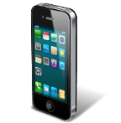

**TEXT PROCESSING USING NLP**

**SYMPTOMS IDENTIFICATION**

**CLASSIFICATION**

**DISEASE PREDICTION**

**TREATMENTS**

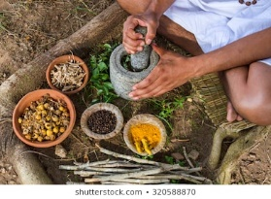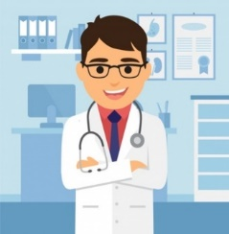

Figure 3.1 Implementation process followed by the proposed system

Considering the generation of the Ayurvedic prescription for diseases which are diagnosed to not be within a critical stage, the proposed system will first determine the stage of the disease. It will then generate the prescription by referring to the database populated previously by referring actual Ayurvedic treatments and doctors. It will also provide a video and audio recording of the treatment to the user to provide a more in depth idea regarding the treatment to the user. The figure below provides a generic step by step description of the process to be followed.

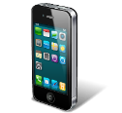

**Identified object**

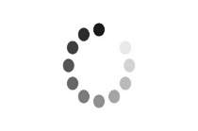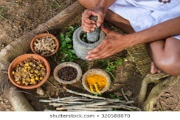

**DISEASE PREDICTION**

Figure 3.2 Prescription of the process

Technologies that we are planning to use,

* Android Studio
* Natural language processing (NLP)
* RASA Library
* Jupyter notebook
* Python
* MatLab

Advantages

* Saves time
* Saves money
* Encourage people to use Ayurvedic medicine
* Provide help to find the disease in private without images

Existing Products

* Ada : Your health companion
* All Skin diseases and treatments
* Dermaphoto
* VisualDx
* Cureskin

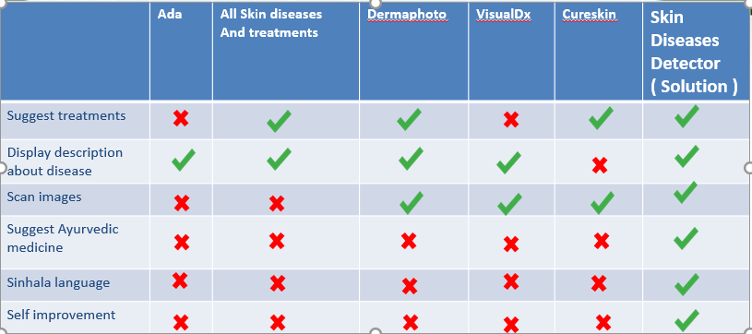

Table 3.1 Comparison Table

**4 WORK BREAKDOWN STRUCTURE**

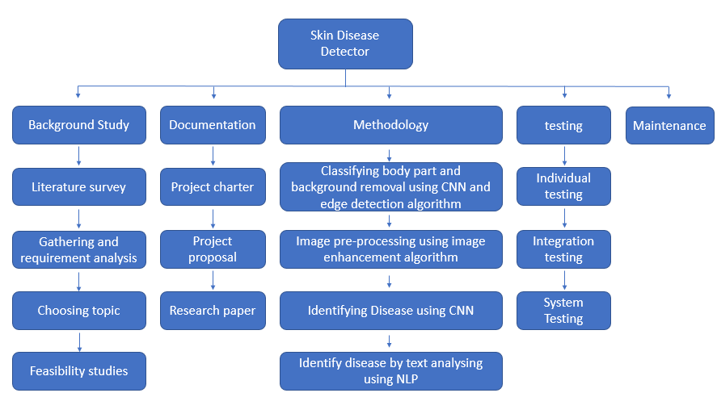

Figure 4.1 Work breakdown structure

**5 COMMERCIAL VALUE**

We are targeting people who infected with skin diseases.

We giving system functions to user with limitations

Free Version

* Display preventing methods
* Display some of Ayurvedic treatments
* Display description about disease

Paid Version

* Allow user to download pdf file that contain every information
* Allow user to access tutorial
* How to make ayurvedic medicines at home

**6 GANTT CHART**

**6 REFERENCES**

[1] R. B. Mathew, S. Varghese, S. E. Joy, and S. S. Alex, “Chatbot for Disease Prediction and Treatment Recommendation using Machine Learning,” *2019 3rd International Conference on Trends in Electronics and Informatics (ICOEI)*, 2019.

[2] N. S. A. Alenezi, “A Method Of Skin Disease Detection Using Image Processing And Machine Learning,” *Procedia Computer Science*, vol. 163, pp. 85–92, 2019.

[3] A.Ajith, V. Goel, P. Vazirani, and M. M. Roja, “Digital dermatology: Skin disease detection model using image processing,” *2017 International Conference on Intelligent Computing and Control Systems (ICICCS)*, 2017.

[4] Vedanti Chintawar and Jignyasa Sanghavi “Improving Feature Selection Capabilities in Skin Disease Detection System,” *2019 International Journal of Innovative Technology and Exploring Engineering (IJITEE)*, 2019.

[5] A. Haddad and S. A. Hameed, “Image Analysis Model For Skin Disease Detection: Framework,” *2018 7th International Conference on Computer and Communication Engineering (ICCCE)*, 2018.

[6] Y. Lu and H. Guo, “Background removal in image indexing and retrieval,” *Proceedings 10th International Conference on Image Analysis and Processing*.